Project Design Phase-II
Data Flow Diagram & User Stories

Date | 31 January 2025
Team ID | 6ab3db806603573ccfb383f7
Project Name | AI FAQ Assistant
Maximum Marks | 4 Marks

Data Flow Diagrams – AI FAQ Assistant
A Data Flow Diagram (DFD) for the AI FAQ Assistant represents how information moves between the user and the system. The user enters a frequently asked question through the application, and the system receives and processes the question using the AI FAQ Assistant. The system searches the available FAQ knowledge base or API for relevant information and generates a suitable response. The answer is then sent back to the user through the application interface. The DFD shows the flow of user questions, processing, FAQ data, AI response generation, and final answers, providing a clear visual representation of how the AI FAQ Assistant system works.

Example: DFD – AI FAQ Assistant
Arranging the pieces

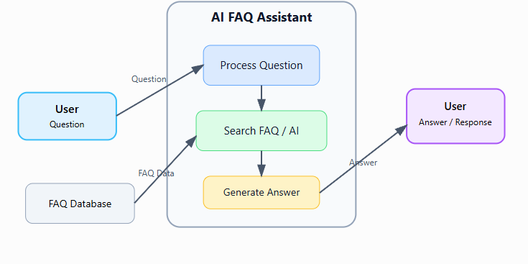
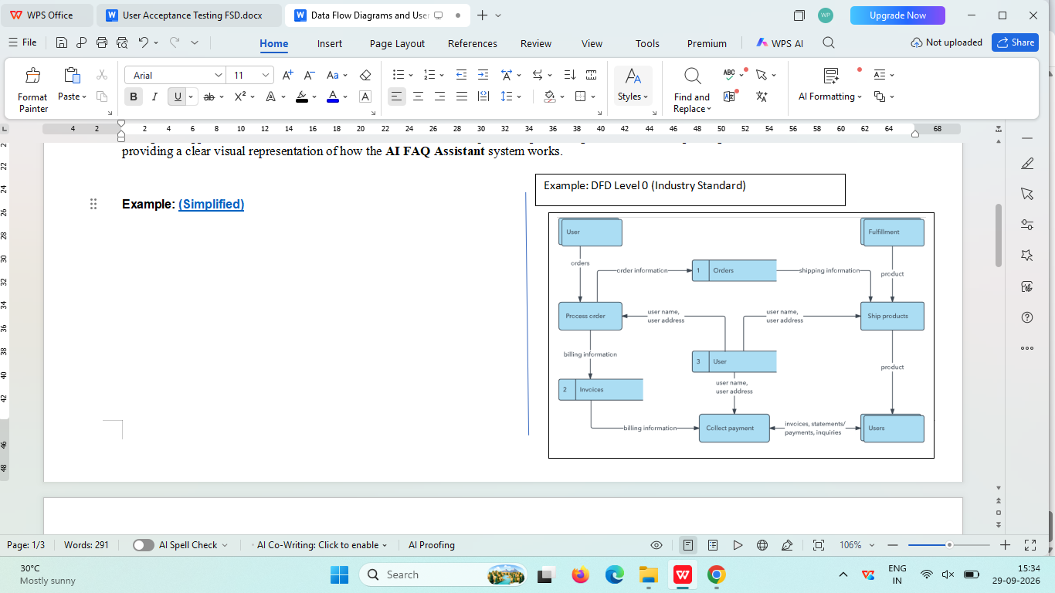

User Type | Functional Requirement (Epic) | User Story Number | User Story / Task | Acceptance Criteria | Priority | Release
User | Registration | USN-1 | As a user, I can register for the AI FAQ Assistant by entering my name, email, username and password. | I can successfully create an account and access the application. | High | Sprint-1
User | Login | USN-2 | As a user, I can log into the application by entering my username and password. | I can successfully log in with valid credentials. | High | Sprint-1
User | Ask FAQ Questions | USN-3 | As a user, I can enter a frequently asked question in the AI FAQ Assistant | The system accepts my question and processes it successfully. | High | Sprint-1
User | AI Answer | USN-4 | As a user, I can receive an AI-generated answer to my question. | A relevant and understandable answer is displayed. | High | Sprint-1
User | FAQ Search | USN-5 | As a user, I can search for answers from the available FAQ information. | Relevant FAQ results are displayed for the entered question. | High | Sprint-1
User | Weather Information | USN-6 | As a user, I can enter a city or location and view weather information. | The system displays available weather details for the selected location. | High | Sprint-2
User | Weather API | USN-7 | As a user, I can receive weather information through the integrated Weather API. | The system retrieves and displays the available weather data successfully. | High | Sprint-2
User | Chat Interface | USN-8 | As a user, I can interact with the AI FAQ Assistant through a simple chat interface. | I can enter questions and view responses in the chat interface. | Medium | Sprint-2
User | Error Handling | USN-9 | As a user, I can receive a suitable message when my question cannot be answered. | The system displays a clear message instead of showing an error. | Medium | Sprint-2
User | Logout | USN-10 | As a user, I can log out of the AI FAQ Assistant securely. | I am logged out and redirected to the login or home page. | Medium | Sprint-2

